DNS
- 2 systems are there (in same network)
A: 192.168.1.10
B: 192.168.1.11 (hostname: db)
network: 192.168.1.0
  - A can ping B with its IP
ping 192.168.1.11 (it’ll work)
  - But, A can’t ping B with its name
ping db (it’ll not work)
- Name Resolution
  - Now, update /etc/hosts of A, about the server B
192.168.1.11 db
[ A can ping B now using ping db ]
  - The name (db) need not be same as B’s hostname.
192.168.1.11 some-server
now, A can ping using ping some-server as well.
  - There can be multiple entries for a specific IP inside /etc/hosts .
  - ping might be disabled in any system, to check if he IP is getting resolved use nslookup command.
nslookup <name>
nslookup some-server
- DNS (Domain Name Server)
  - In previous method, we need to write the IP and Name mappings on each systems /etc/hosts file.
If any system’s IP got changed, then need to update all the systems.
  - DNS server contains all the IP-Name mapping, and every system will ask DNS server to give the respective IP.
Now, if any IP changes, only one place needs to be updated i.e. DNS Server.
  - Consider a DNS server with IP: 192.168.1.100 (same network as of A & B)
  - Then add this nameserver (DNS Server) in the file /etc/resolv.conf of each systems (A, B ..etc)
nameserver 192.168.1.100
  - Now every system will ask this nameserver for the IP of a specific name.
And, in case of IP change, just update this nameserver.
  - If any server that is not needed for all, and needed only for A.
then, /etc/hosts of A can be updated with that new server so that only A can resolve its IP.
192.168.1.115 test (A’s /etc/hosts)
  - Let say the same name (test) is being present inside nameserver as well but with another IP
192.168.1.125 test [ inside nameserver (192.168.1.100) ]
  - Now, if A try to ping this test,
ping test
first it’ll check /etc/hosts of A, then goes for nameserver.
So, for A it’ll be 192.168.1.115 where as for others (who doesn’t contain entry for test in their respective /etc/hosts), it’ll be 192.168.1.125 (nameserver’s entry)
  - This order can be changed.
There is a file /etc/nsswitch.conf inside which one entry will be there
hosts: files dns
[ files means /etc/hosts, dns means nameserver ]
It means first check /etc/hosts and then check nameserver.
If you write it opposite then it’ll change
hosts: dns files
  - Lets say you are trying to ping a server which is not there in either list (/etc/hosts & nameserver),
for example: ping facebook.com
It’ll fail.
  - In this case, you can add a nameserver who knows this server (facebook.com) inside /etc/resolv.conf file.
Now, /etc/resolv.conf has 2 nameservers configured:
nameserver 192.168.1.100
nameserver 8.8.8.8 (public DNS server provided by Google)
[ 8.8.8.8 can extract all the domains throughout the internet; because it’s a Recursive DNS service ]
- Domain name
  - <sub-domain>.<sub-domain>.<domain>.<TLD>
(sub-domain can be multiple, not limited to 2)
    - www.google.com, maps.google.com
www, maps: sub-domain
google: domain
.com: TLD (Top Level Domain)
    - . is the Root -> then domain -> then subdomains.
  - Full actual domain look like this,
www.google.com.
[ that dot (.) at the end is Root ]
- Flow of domain resolving to IP
  - Let say you tried to access apps.google.com .
  - it’ll check your local /etc/hosts file.
[ it is not there let say ]
  - It’ll go to your organization’s DNS server to check if there is any entry of this.
[ it is not there let say ]
  - Either your /etc/resolv.conf has a public DNS (nameserver 8.8.8.8) or your organization’s DNS forward this to a public DNS.
  - Request goes to public DNS.
    - Public DNS are Recursive.
It means they recursively fetch the IP from domain starting from root to domain level.
    - First, Recursive DNS will ask the Root DNS if any entry for apps.google.com is there.
[ Root DNS: . ]
Root DNS responds with the TLD (.com)’s DNS server.
    - Recursive DNS will ask TLD if there is entry of apps.google.com is there.
[ TLD: .com in our case ]
TLD responds with the google.com DNS server.
    - Recursive DNS will ask google.com DNS server about apps.google.com
either google.com DNS server would have contained all the domains like maps.google.com, apps.google.com, www.google.com ..etc.
Or there might be other DNS servers containing the sub-domains. (in this case Recursive DNS ask that server about the domain apps.google.com )
  - now the IP is fetched and it’ll be stored in cache (in organization’s DNS) for few seconds or minutes.
  - 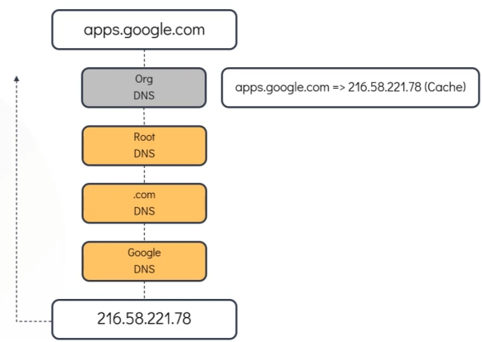
- Let say your organization has so many sub-domains like
hr, pay, drive, mail, sql ..etc.
And domain is: mycompany.com
  - Outsiders should give full domain to access these like
hr.mycompany.com, mail.mycompany.com ..etc.
  - But people of the company itself, they shouldn’t write full name.
They should be able to access like hr, pay, drive ..etc.
  - For example, they just write hr and it’ll be converted to hr.mycompany.com
  - But inside the internal DNS server, full domain is present like
hr.mycompany.com, mail.mycompany.com ..etc.
  - You can write search in /etc/resolv.conf like the below
nameserver 192.168.1.100
search mycompany.com prod.mycompany.com
    - Order matters, it’ll be checked from left to right till the valid domain is got.
hr.mycompany.com, hr.prod.mycompany.com …like this.
- Record Types
  - A
name to IPv4
  - AAAA
name to IPv6
  - CNAME
name to name
  - 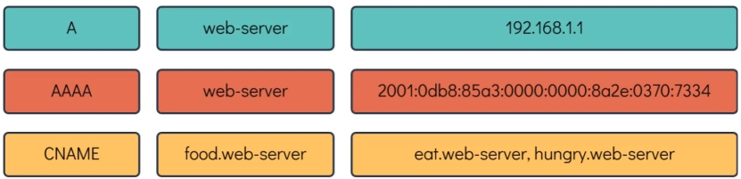
- ping is not always the right tool to check DNS resolution.
  - nslookup can be used to query a hostname from a DNS Server.
It doesn’t consider entries inside /etc/hosts file contents.
  - dig returns more details than nslookup. And it is used widely.
- DNS is interface scoped.
  - Let say you have 2 network interfaces, one connected to internal DNS and another to Internet.
  - In modern systems, /etc/resolv.conf doesn’t contain the nameservers directly, instead it contains the below
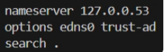
It means “Send all DNS queries to local systemd-resolved service”
  - systemd-resolved is a systemctl service [ you can see via systemctl cat systemd-resolved ] which internally maintains DNS per interface.
  - In modern system, /etc/resolv.conf is not changed mostly, rather DNS is provided at interface level.
  - resolvectl status
this gives the DNS details of each interfaces.
  - If 2 interfaces contains 2 DNS servers, and in both one common name is present with different IPs.
test: 192.168.5.16 (dns server 1)
test: 192.168.10.17 (dns server 2)
here the systemd-resolved is the main. Whatever it selects become the final.
- Global nameservers can also be added.
/etc/systemd/resolved.conf
[ space separated dns server IPs. Like, 8.8.8.8 1.1.1.1 ]
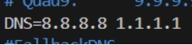
  - Question is: through which interface global DNS will be resolved?
    - It’ll be fetched from the routing table.
    - If not present, then default gateway.
- Whatever the type of nameservers (interface level or global), systemd-resolved only choose the nameserver.

- F
- F
- F
- F

Linux Namespace
- Network Namespace is a separate network inside the host.
  - Host and Namespace doesn’t know anything about each other.
- The namespace will have its own network interfaces, arp table, routing table (independent of Host).
- I’ve 2 vms: vm1, vm2
vm1: 10.10.10.10/24
vm2: 10.10.10.11/24
- vm1 and vm2 can ping each other
because both belong to same LAN (10.10.10.x).
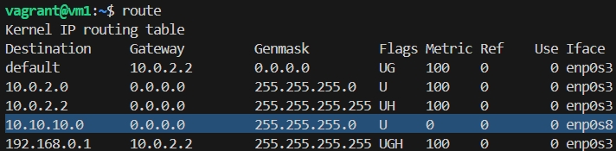[vm1 route table]
Gateway 0.0.0.0 means this subnet (10.10.10.0) Gateway/Router is not needed because both belong to same subnet.
10.10.10.0 is added on enp0s8 (means this interface is connected to private network i.e. vm to vm communication)
route doesn’t depend only on Gateway, it needs to know through which network interface traffic should be sent. However, kernel finds it by itself seeing the gateway IP.
- ip add
display all the network interfaces names like l0 (loopback), enp0s3, enp0s8 ..etc.
en: ethernet; p0: PCI bus 0; s3: slot 3
enp0s8: ethernet device on slot 8
in our VM (vm1, vm2), lo enp0s3 enp0s8 will be there.
s3 is for vm-to-vm communication (inter LAN), s8 is for internet access (NAT).
- To create a namespace
ip netns add <namespace name>
  - We’ll create 2 namespaces having name red, blue .
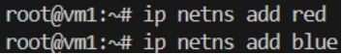
  - ip netns list
to list all the namespaces
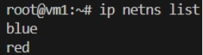
- To execute any command inside a namespace
ip netns exec <network namespace name> <command to execute>
  - ip netns exec red ip add
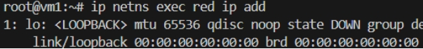
[ only loopback is present ]
[ same for blue namespace as well ]
  - ip netns exec red route
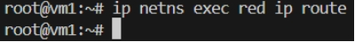
[ no route is present ]
[ same for blue namespace as well ]
- Now we’ll create a veth pair (just like a virtual cable) to connect the 2 namespaces.
ip link add <veth’s one end name> type veth peer name <veth’s another end name>
[ when you create a veth pair, it creates 2 veth network interface in the host and connect them internally. From outside, it looks 2 ends of a virtual ethernet cable ]
  - ip link add veth-red type veth peer name veth-blue
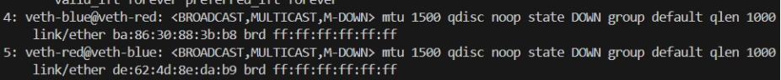 [ ip add ]
[ 2 veth network interface; internally connected; both represents one one end ]
veth-blue@veth-red -> veth-blue interface is connected to veth-red
veth-red@veth-blue -> veth-red interface is connected to veth-blue
  - If both the ends of a veth pair present in same place (ex: both in host), then it is displayed like
end1-name@end2-name (end1 to end2)
end2-name@end1-name (end2 to end1)
if both are present in different namespaces (host & namespace; or namespace1 & namespace2), then it’ll be displayed like
end1-name@if<end2’s index at its namespace>
end2-name@if<end1’s index at its namespace>
- To connect veth ends to namespaces
ip link set <veth end name> netns <network namespace name>
- Connect veth-red end to the namespace red
ip link set veth-red netns red
  - Now if you see,
link-netns red it means other end is present in namespace red.
  - veth-red@veth-blue is gone
because veth-red is now connected to a namespace. Host linux (host) cannot show peer interface directly it moved to namespace.
  - veth-blue@veth-red got updated to veth-blue@if5 because veth-red’s index inside namespace red is 5.
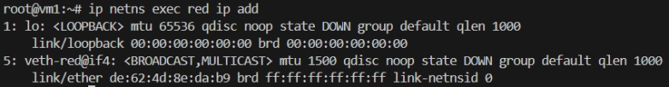
[ ip netns exec red ip add ]
And also, here, veth-red@if4 because veth-blue is at 4th index .
link-netnsid 0 means other end present in host.
- Connect veth-blue to the namespace blue
ip link set veth-blue netns blue
  - Now, veth-blue will be gone from host because it belongs to namespace blue.
- Network interfaces in both namespace now
  - Namespace red:
ip netns exec red ip add
    - 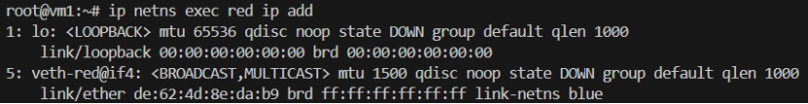
    - link-netns blue : other end is in namespace blue
  - Namespace blue:
ip netns exec blue ip add
    - 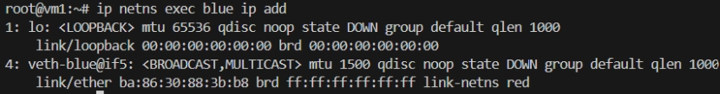
    - link-netns red : other end is in namespace red
- Now make the network interfaces in both namespaces UP.
ip netns exec <network namespace name> ip link set <interface name> up
  - ip netns exec red ip link set lo up
ip netns exec red ip link set veth-red up
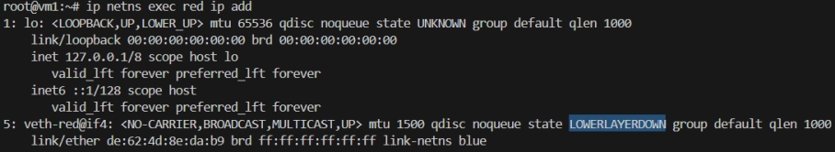
LOWERLAYERDOWN: means it is up, but its other end (veth-blue) is down.
  - ip netns exec red ip link set lo up
ip netns exec red ip link set veth-red up
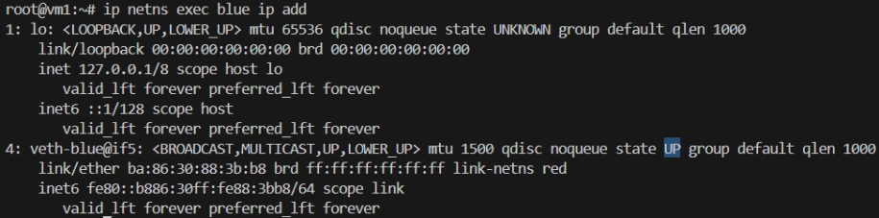
  - Now, both veth-red and veth-blue are UP.
- Assign IP to both the namespace
ip netns exec <namespace name> ip addr add <IP>/<subnet mask length> dev <interface name>
  - Assign in namespace red:
ip netns exec red ip addr add 192.168.15.2/24 dev veth-red
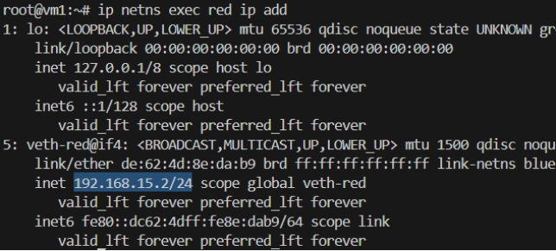
[ IP is assigned ]
  - Assign in namespace blue:
ip netns exec blue ip addr add 192.168.15.3/24 dev veth-blue
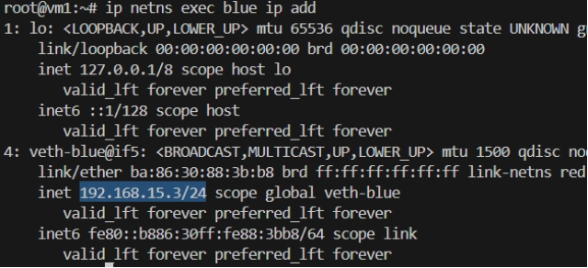
  - The IPs are 192.168.15.2/24 & 192.168.15.3/24,
so private LAN’s network IP will be: 198.168.15.0
& subnet mask will be: 255.255.255.0
- Ping the namespaces from each other. It’ll work fine.
  - From namespace red:
ip netns exec red ping -c 4 192.168.15.3
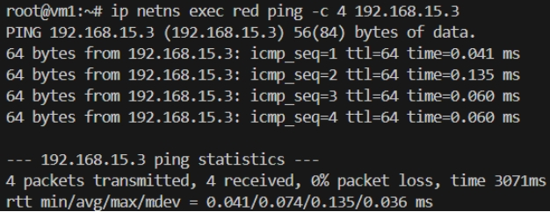
  - From namespace blue:
ip netns exec blue ping -c 4 192.168.15.2
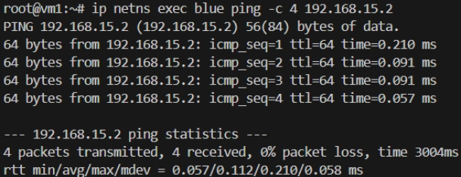
- Check arp table in both namespace, it should be updated.
  - In namespace red:
  - In namespace blue:
- But in Host’s arp table, nothing related to namespaces will be there.
Because both are separate.
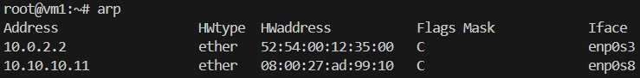
- Try to ping the namespaces from Host.
ping -c 4 <namespace network interface IP>
  - Ping to namespace red:
ping -c 4 192.168.15.2
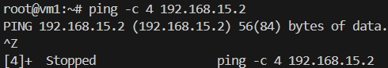
FAILED
  - Ping to namespace red
ping -c 4 192.168.15.3
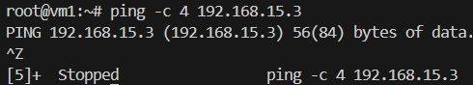
FAILED
  - It is failing because there is no connection between host and namespaces.
Create a veth pair and connect that to host and namespace, then only you can ping.
[ however, both end present in the host initially, just connect one to a namespace ]
- To test connection between host and a namespace (let red), create a veth pair and connect one end to the namespace.
Another end will be by default connected to host.
  - ip link add veth2-red type veth peer name veth2-red-host [ create veth pair ]
  - ip link set veth2-red netns red [ connect veth2-red end to namespace red ]
  - ip netns exec red ip link set veth2-red up [ make the link up in namespace ]
  - ip link set veth2-red-host up [ make the link up in host ]
  - netns exec red ip addr add 192.168.25.2/24 dev veth2-red [ assign ip in namespace ]
  - ip addr add 192.168.25.3/24 dev veth2-red-host [ assign ip in host ]
  - ping -c 4 192.168.25.2 (ping from host to namespace)
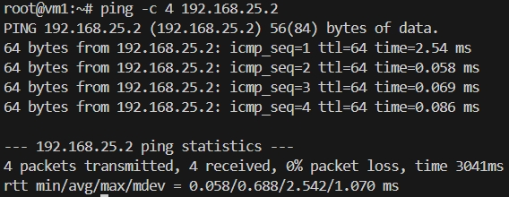
  - ip netns exec red ping -c 4 192.168.25.3 (ping from namespace to host)
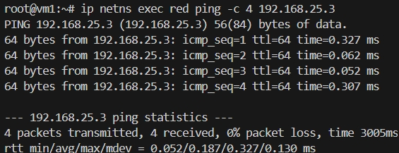
  - Here we did the same thing, before connected veth pair from namespace to namespace; not connected veth pair from host to namespace.
But, we had pinged to 192.168.25.2 (not 15.2 which is previous veth’s subnet)
  - You can add gateway in host
ip route add <network-ip> via <gateway-ip>
ip route add 192.168.15.0 via 192.168.25.2
but need to enable packet forwarding inside namespace red. Because linux doesn’t forward packets by default.
  - But, one issue will be there,
we configured 192.168.15.0 via 192.168.25.2
but the namespace blue also have this subnet, for that also it’ll send to red namespace because gateway is 192.168.25.2
  - We’ll do this in broader picture; not namespace level;
- We had 2 namespaces so one veth and directly connect both.
In case of multiple namespaces, need to create a bridge.
[ inside linux, virtual switch can be created ]
- Delete all the veth pairs.
ip link delete <any one end name>
[ it’ll delete the other name by default ]
  - ip netns exec red ip link delete veth-red
  - ip link delete veth2-red-host
- Create a bridge
ip link add <bridge interface name> type bridge
  - ip link add v-net-0 type bridge
  - [ ip add ]
its coming as a normal network interface only.
  - Linux bridge is nothing but a network interface like others.
  - The bridge belongs to the namespace where it is created.
If created in host, it belong to the host.
If created in a namespace, it belong to that namespace.
- Make the bridge network interface UP.
ip link set v-net-0 up
- Now create a veth pair, connect one end to the namespace red and another to bridge.
  - ip link add veth-red type veth peer name veth-red-br [ create veth pair ]
  - ip link set veth-red netns red [ connect one end to namespace red ]
  - Now in host [ ip add ]
  - ip link set veth-red-br master v-net-0 [ connect another end to bridge ]
[ for master node’s interface, use master <host’s interface name> ]
  - ip netns exec red ip link set veth-red up [ make namespace end up ]
  - ip link set veth-red-br up [ make bridge end up ]
- Do the same for blue namespace.
  - ip link add veth-blue type veth peer name veth-blue-br [ create veth pair ]
  - ip link set veth-blue netns blue [ connect one end to namespace red ]
  - Now in host [ ip add ]
  - ip link set veth-blue-br master v-net-0 [ connect another end to bridge ]
  - ip netns exec blue ip link set veth-blue up [ make namespace end up ]
  - ip link set veth-blue-br up [ make bridge end up ]
- Now assign IPs to both red and blue namespace
  - ip netns exec red ip addr add 192.168.15.2/24 dev veth-red [ assign IP to red namespace ]
  - ip netns exec blue ip addr add 192.168.15.3/24 dev veth-blue [ assign IP to blue namespace ]
- Now, ping from one namespace to another will be successful.
  - Ping red to blue
ip netns exec red ping -c 4 192.168.15.3
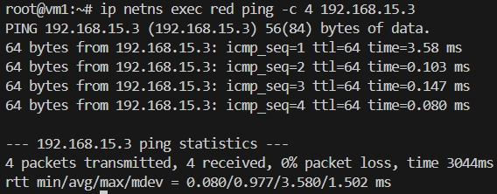
  - Ping from blue to red
ip netns exec red ping -c 4 192.168.15.3
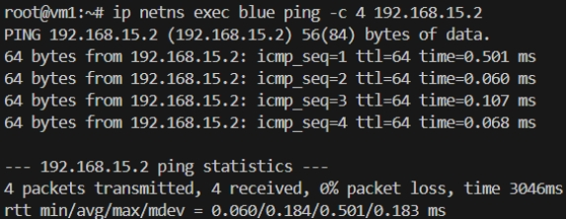
- But, Host cannot ping either of these namespace
  - Host to namespace red
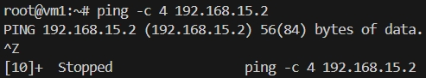
  - Host to namespace blue
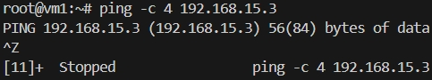
- Add IP address to the bridge network interface (v-net-0)
ip addr add 192.168.15.5/24 dev v-net-0
  - Because till now host doesn’t know any subnet of 102.168.15.x
- Now try to ping again.
  - Not it’ll be successful
because, host has now a interface having the same subnet as that of the namespaces.
  - Host to namespace red
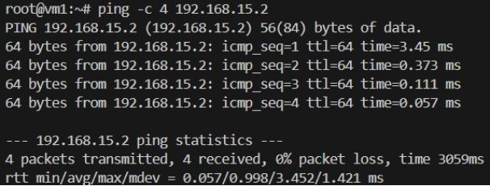
  - Host to namespace blue
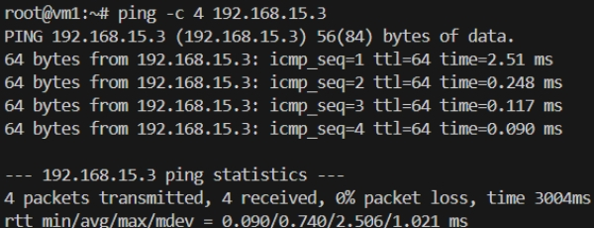
- Ping from namespace to host should also work.
But to 102.168.15.5 (bridge network interface IP) only.
It’ll not work for 10.10.10.10 (host (vm1) IP)
  - Namespace red to host
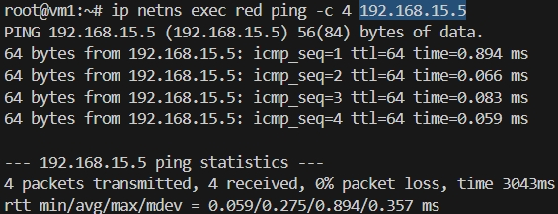
  - Namespace blue to host.
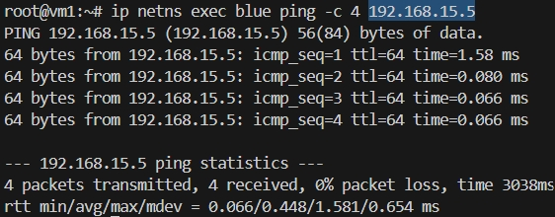
  - To 10.10.10.10 will not work
[ ‘Network is unreachable’ comes when gateway is not there ]
- Add gateway in the namespaces
network subnet: 10.10.10.0
gateway: 192.168.15.5 [ bridge network interface’s IP]
[ means to communicate with 10.10.10.0, route to 192.168.15.5 (bridge’s IP) ]
  - ip netns exec red ip route add 10.10.10.0/24 via 192.168.15.5 [ in namespace red ]
  - ip netns exec blue ip route add 10.10.10.0/24 via 192.168.15.5 [ in namespace blue ]
[ always add the subnet /24, otherwise it’ll take /32 by default ]
- Now try to ping host (10.10.10.10) from namespaces
  - Namespace red to host
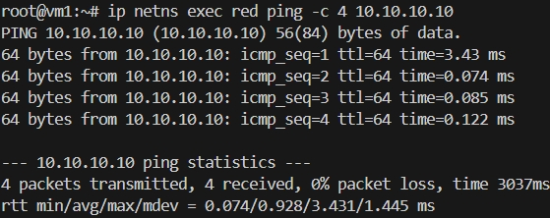
  - Namespace blue to host
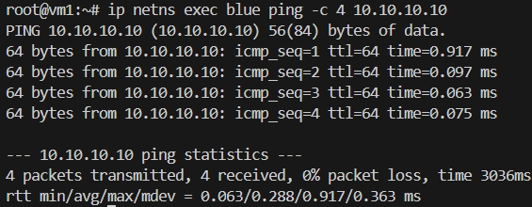
- Now try to ping vm2 (10.10.10.11) from the namespaces.
It’ll ping (because gateway is there) but response will not come.
  - Namespace red to vm2
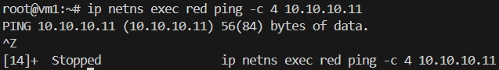
  - Namespace blue to vm2
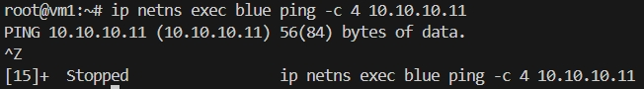
  - It is because, packet is going to vm2 (10.10.10.11), but it doesn’t know about 192.168.15.x because it belongs to private network of vm1 (host).
  - Either add a gateway in vm2 or enable NAT in vm1.
- Option-1: adding gateway in vm2
network: 192.168.15.0
gateway: 10.10.10.10 (vm1 / host)
[ means to communicate with 192.168.15.0 subnet, route to 10.10.10.10 ]
  - ip route add 192.168.15.0/24 via 10.10.10.10 [ vm2 ]
  - 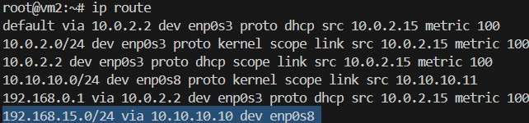 [ vm2 ]
[ ip route ]
  - Even now ping from namespace to vm2 or vice-versa will not work.
Because, IP forwarding is disable in vm1 (host)
cat /proc/sys/net/ipv4/ip_forward
0: disabled
1: enabled
  - vm1 OS is acting as the gateway and router for different networks.
10.10.10.x network & 192.168.15.x network.
  - A router’s main job is to receive packet from a network, and forward that to another network.
Here, vm1 OS is acting as a router, receiving from one network and forwarding to another. So, packet forwarding needs to be enabled.
  - Enable ip forwarding
echo 1 > /proc/sys/net/ipv4/ip_forward
  - Now ping will work
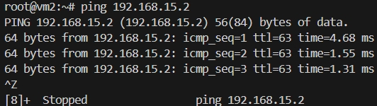 [ vm2 to namespace ]
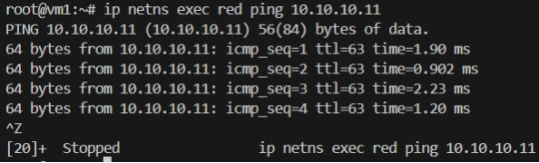 [ namespace t vm2 ]
  - In this case, vm2 can directly communicate to namespace (of vm1).
- Option-2: using NAT
  - Previous option is not preferable because if multiple systems will be there, in each system we need to set route gateway.
  - If we enable NAT in vm1, it’ll update the source IP before the packet exits.
    - Packet before NAT:
src IP: 192.168.15.2 (red namespace)
dest IP: 10.10.10.11 (vm2)
    - Packet after NAT:
src IP: 10.10.10.10 (host/vm1 IP)
dest IP: 10.10.10.11 (vm2) --> it doesn’t change.
  - Now the packet can go to vm2 easily, and vm2 as well send back the response.
src IP: 10.10.10.11
dest IP: 10.10.10.10 (because this was the source IP received at vm2)
  - vm1 (host) will receive the packet. And from the NAT table it knows that this packet belong to 192.168.15.2 (red namespace).
Now it updates the packet’s dest IP
src IP: 10.10.10.11 (vm2, doesn’t change)
dest IP: 192.158.15.2 (red namespace)
  - To setup this, First delete the created configs (vm2 route gateway).
Don’t disable IP packet forwarding (/proc/sys/net/ipv4/ip_forward) because NAT requires this.
  - iptables -t nat -A POSTROUTING -o <network interface name> -j MASQUERADE
-t: use NAT table
POSTROUTING: modify packet before leaving
<network interface name>: network interface connected to vm2
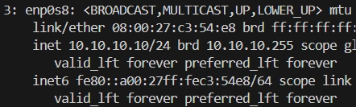 [ in my case enp0s8 ]
MASQUERADE: replace source IP with host/router IP
[ for incoming traffic, destination ip will be updated (host IP to namespace’s IP). it looks like DNAT but it is not. Kernel automatically reverse NAT mapping because it remembers previously source IP was changed ]
    - iptables -t nat -A POSTROUTING -o enp0s8 -j MASQUERADE
  - Now, from namespace to vm2 can be easily accessible.
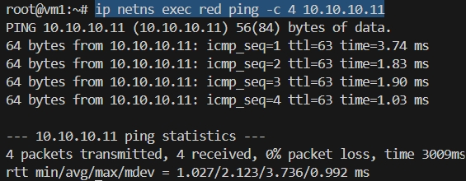 [red to vm2]
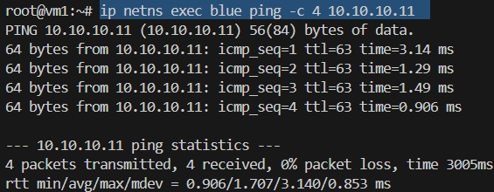 [blue to vm2]
  - But, vm2 to namespace will not be accessible.
Namespace to vm2:
when vm2 receives the packet, src ip: vm1’s ip, dest ip: vm2’s ip
so, vm2 also sends the packet, src ip: vm2’s ip, dest ip: vm1’s ip
at the end, vm1 forward the packet to namespace.
[ in this scenario, vm2 is sending packet to vm1 only, not to namespace ]
  - But, directly if you try to access namespace from vm2 it’ll not work because vm2 doesn’t know about namespace.
If you want this only, then route needs to be added in vm2 .
  - Port forwarding can be used in this case.
Vm2 will send packet to vm1 at a particular port. Vm1 will forward the packet to namespace.
It is DNAT.
  - iptables -t nat -A PREROUTING -p tcp --dport 8080 -j DNAT --to-destination 192.168.15.2:80
Packets arriving on port 8080 should be redirected to namespace 192.168.15.2:80
  - I ran a simple nodejs in namespace red on port 80,
curl http://10.10.10.10:8080 [ from vm2 ]
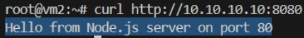

- Creating namespace and checking the things
  - 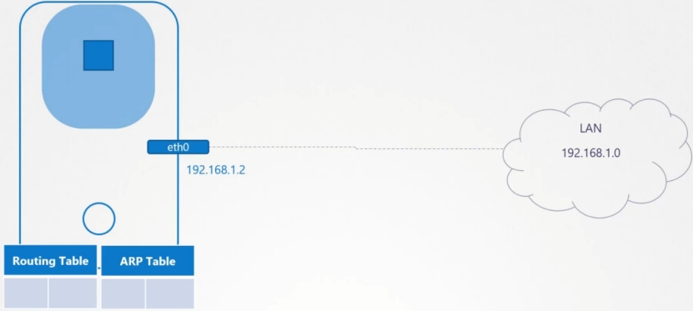
[ note the IP: 192.168.1.2 ]
the host might have connected to a LAN and got a IP from that swtich.
But, the namespace that will be created inside the Host will not have any idea about it.
It’ll be completely different and will not be aware about the host.
  - Lets say we created 2 network namespaced (red and blue) inside the host.
ip netns add red
ip netns add blue

  - When you execute ip link on the host, it’ll display some interfaces like
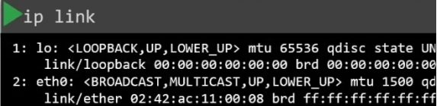
But when you execute the same inside the namespaces
ip netns exec red ip link
only one loopback will be there
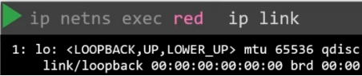
(similarly for blue namespace )
NOTE: whatever command needs to be executed inside the namespace,
ip netns exec <namespace name> <command to execute>
  - Same for arp as well.
In the host:
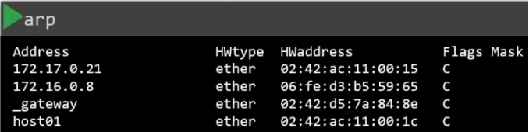
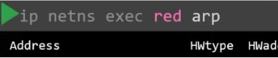 [ nothing is there inside the namespace ]
  - Same for route as well.
In the host:
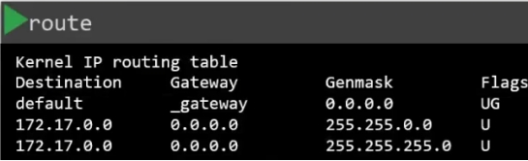
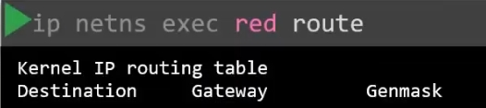 [ nothing is there inside the namespace ]
  - To connect the 2 namespaces, we need to connect a cable between them.
That cable is nothing but veth pair.
  - Create a veth pair.
ip link add veth-red type veth peer name veth-blue
here, veth-red and veth-blue are just the names of the 2 ends of the veth pair.
  - When you create a veth, it is created in the HOST’s namespace. You need to direct that towards the required namespace.
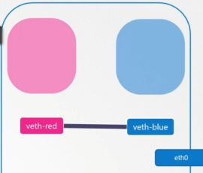
  - ip link set <veth’s end name> netns <network namespace name>
ip link set veth-red netns red
ip link set veth-blue netns blue
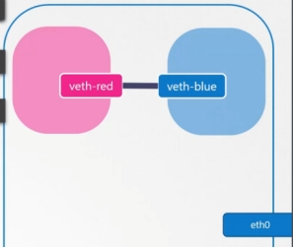
  - Now we’ll assign IP to each namespaces.
ip -n <namespace name> addr add <ip address> dev <interface name like eth0>
(or)
ip netns exec <namespace name> ip addr add <ip address> dev <interface name>
[ both are same, ip command contains a flag -n to provide namespace so it can be used like that as well ]
    - Now, both namespaces (red and blue) are having one one interface veth-red and veth-blue respectively having some IPs.
[here IPs are 192.168.15.x range, but the Host’s IP is in 192.168.1.x range ]
  - Now, make those interfaces up.
ip -n <namespace name> link set <interface name> up
(or)
ip netns exec <namespace name> ip link set <interface name> up
  - If you try to ping blue namespace from red, it’ll be able to ping.
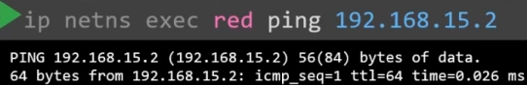
  - After pinging, the arp table should be updated in both the namespaces.
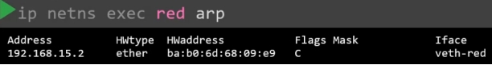
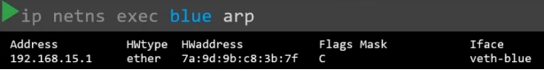
  - 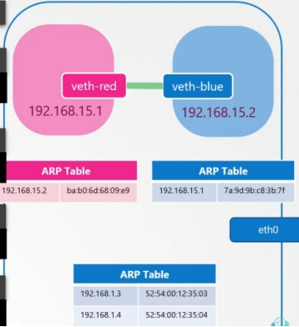
  - If you see host’s arp table
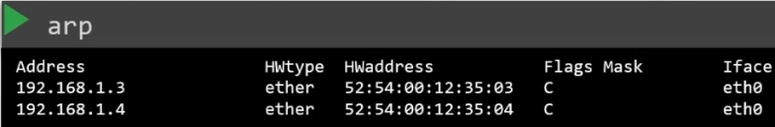
it has no idea about namespaces
- Till now we had only 2 namespaces, now multiple namespaces
  - You need to create a virtual switch to create a virtual network to which all the namespaces will be connected.
  - There are multiple option to create a virtual bridge like
linux bridge (native solution) [ we’ll gonna use this ]
Open vSwitch
  - We’ll create a virtual switch using
ip link add <bridge interface name> type bridge
it’ll appear as a normal interface in the Host just like eth0 interface.
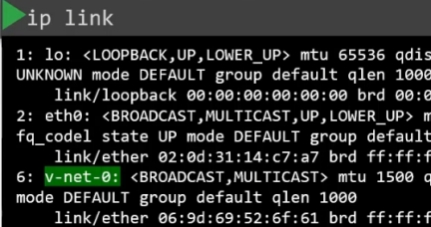 [ v-net-0 is there as a normal interfacce ]
  - Now, make the interface UP.
  - Previously we connected the veth pair to both the namespaces (one end to red and another to blue).
But now, we’ll connect one end to a namespace and another to bridge (virtual switch).
  - First delete the previously created veth pair .
ip -n <namespace name> link delete <veth pair end>
(or)
ip netns exec <namespace name> ip link delete <veth pair end>
[just delete one end of veth pair, other end will be deleted automatically]
  - Now create a veth pair which will connect the namespace to bridge.
(just for convention, we’ll give one end veth-red, and another veth-red-br )

similarly for blue namespace

  - Now we’ll connect the veth pair to namespace and bridge.
One end to namespace red:
ip link set veth-red netns red
Another end to bridge:
ip link set veth-red-br master v-net-0
for namespace, netns <namespace name>, and for host master <interface name>
do the same for blue namespace.
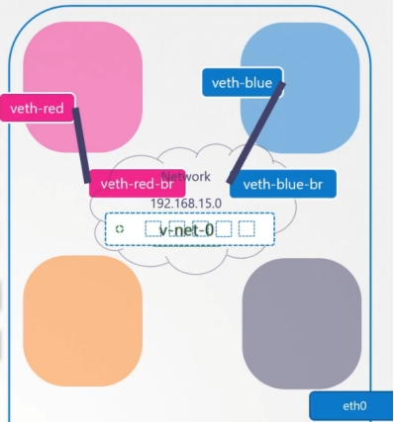
  - Now set IP address for the link and turn them UP.
  - 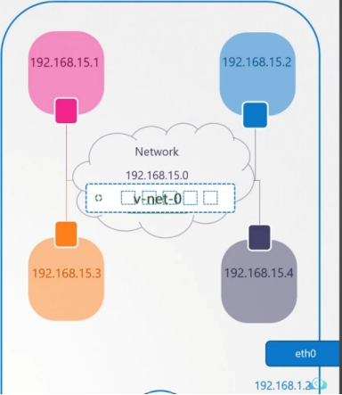
  - But, if you now try to ping any of these namespaces from the Host, it’ll be unreachable because they are in different network.
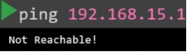
  - Now, all namespaces have some IPs but the switch doesn’t have any IP.
(its layer 2, ping is a layer-3 protocol, it needs an IP).
  - Assign a IP 192.168.15.5/24 to the bridge interface (no need to manually assign subnet 192.168.15.0 as shown in the previous image).
ip addr add 198.168.15.5/24 dev v-net-0
  - Now the ping will be successful.
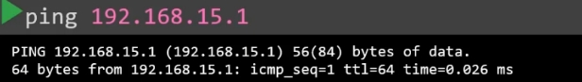
  - Till now, only the Host and Namespaces can communicate.
But, the namespace can’t communicate with the internet.
The only door to the outside world is the ethernet port on the host (eth0).
  - Lets say a device (lets say device-2) is connected to the same LAN (to which the Host is connected) and its IP is: 192.168.1.3 (host’s IP is 192.168.1.2)
  - Now, if we try to ping that device-2 from blue namespace, it’ll be not reachable.
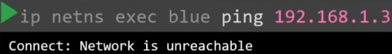
If you see the route table of blue namespace, it doesn’t contain any entry for 192.168.1.x range IPs.
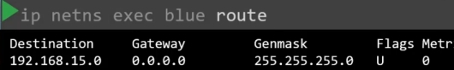 [ it just knows its own subnet ]
NOTE: It is not the default gw. For default gw the entry looks like the below
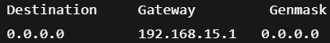
  - Who contains both the network interfaces i.e. bridge network interface and eth0 .
It is localhost.
It is connected to the private network (192.168.15.x) and the outside network (192.168.1.x).
  - localhost is the gateway that connects the 2 networks together.
  - To add a gateway,
ip route add <destination> via <gateway>
  - We’ll add the gateway as 192.168.15.5 (bridge interface IP) to connect to LAN (192.168.1.0)
(because previously no gateway was there)
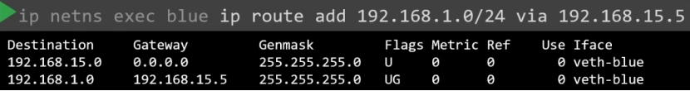
  - Now if you ping device-2 it’ll no longer say not reachable.
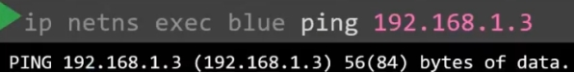
but, it’ll not get any response back.
  - Now the issue of not getting response is the below:
    - The device-2 only recognize our host because both belong to same network (192.168.1.x).
    - When the namespace send the packet to device-2, it goes through the virtual switch (192.168.15.5).
localhost acts as a gateway for connecting bridge interface and ethernet (eth0).
    - So,
namespace (192.168.15.2) ---> bridge interface (192.168.15.5) --> localhost (gateway) --> eth0 (192.168.1.2) --> device-2 (192.168.1.3)
    - But, device-2 doesn’t know about 192.158.15.x ip address range.
So it doesn’t know what is the gateway or to which it should send back the packets.
    - One option is:
you set the gateway as host IP (192.168.1.2) to reach namespaces (192.168.15.0) in device-2.
But, if you do this way, in all the devices you need to add the route like this. VERY HARD TO MANAGE.
Then device-2 can send the response properly.
    - Another option is NAT
Host rewrites source IP before packet leaves.
    - Packet before NAT
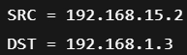
    - Packet after NAT
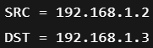
    - Now, device-2 knows this IP, and can easily send the response back.
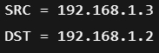 (src is device-1, dst is host)
    - Host receives the packet.
    - Host NAT table remembers that this packet’s destination is 192.158.15.2 , so it rewrites the destination.
    - Now, the packet is successfully sent to the namespace.
  - To add NAT
lets say packet’s path is like this
before packet leaves the host, linux get a last chance to edit this. This stage: POSTROUTING (means: after route decided, before packet exits)
MASQUERADE means replace src IP with host IP
[ 192.168.15.x with 192.168.1.2 ]
  - Now, to reach to internet, (try to ping 8.8.8.8), you need to set the default gateway as bridge network interface’s IP (192.168.15.2)
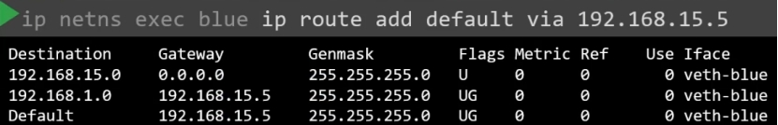
  - 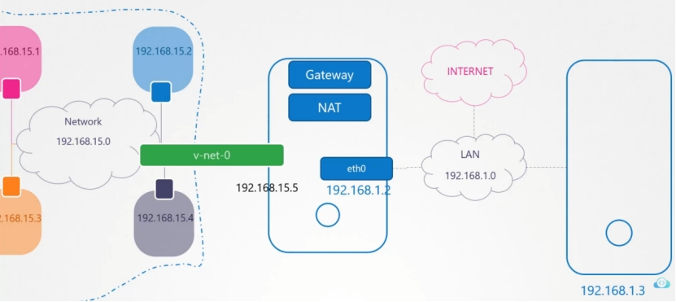
  - SNAT: change source IP
DNAT: change destination IP

- What is bridge?
  - Bridge is a virtual switch in Linux.
Similar to physical switches, WiFi route switches.
  - Linux can create software switches.
ip link add <switch name> type bridge
you can attach interfaces to it [ just like plugging cables into switch ports ]
  - Bridge is required for pods of the same node to communicate.
  - Now all pods are on same virtual LAN (vlan).
  - NOTE: if you create a bridge in linux, it’ll be inside HOST namespace.
- What is veth pair?
  - Pods are inside a separate network namespace than the host.
Need something to connect those.
  - One end of veth is connected to Host Network Namespace,
Another end is connected to Pod Network Namespace.
  - 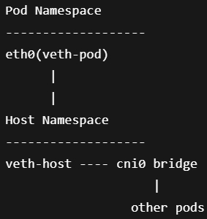
    - veth-pod (veth’s side connected to pod network namespace) will be renamed eth0 inside Pod network namespace.
- What CNI actually does?
  - Create a network namespace (Pod network).
  - Create a veth pair (virtual cable).
  - Connects one end to bridge, another to pod namespace.
  - Give Pod an IP.
  - Add route + gateway
  - Enable NAT (optional for internet).

IPv4 & IPv6 Networking & Hostname Resolution
- ip command just shows and configure the current network settings, but this is not permanent.
  - Different system uses different tools for these.
  - Ubuntu uses NetPlan.
  - netplan get
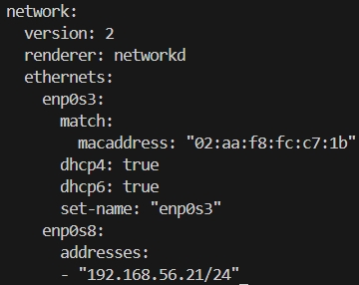
for enp0s3 : dhcp4 & dhcp6 are true.
For enp0s8: static IP is assigned.
  - netplan config files are present inside the directory /etc/netplan/
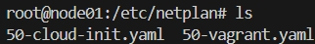
  - We can create a config file by ourselves.
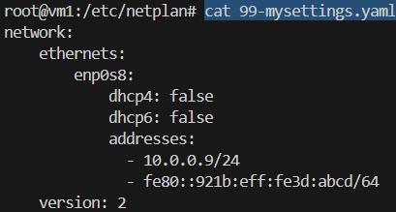
[ name of the file does matter; all the files will be selected in alphabetical order ]
  - You can apply the configs with
netplan apply
but, after applying the connection might be lost. So use
netplan try
it’ll rollback in case of any issue.
  - 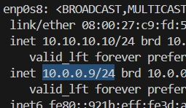
  - Now if we execute netplan get command, it’ll display the new configs
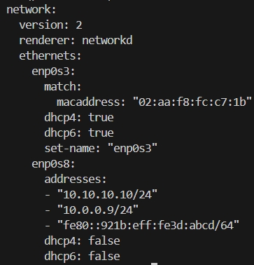
  - Now, even after rebooting, these changes will be kept applied.
It is permanent.
  - Some more fields can be added, like nameservers, gateway
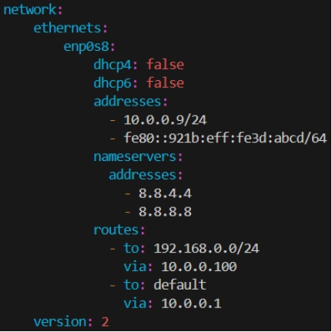
    - if you add gateway using ip route add command, no need to give network interface. Kernel itself finds out the interface seeing the gateway IP.
    - But if gateway is not there and you don’t want to add it via ip route add every time, then just write in required network interface level (which would have been selected by kernel by default if route added via command ip route add) ]

Start, Stop & Check status of Network Interfaces
- ss -ltunp
  - -l : listening
  - -t : TCP connections
  - -u : UDP connections
  - -n : numeric values
  - -p : processes

- F
- F
- F
- F
- F

- Linux Networking Commands
  - ip addr
displays all the network interfaces
ip -c addr
display with colors, readable. [ ip addr -c ]
  - ip link set dev <network interface> up
make the net interface up. [ for making down, just replace up with down ]
  - ip addr add <IP address>/<subnet length> dev <network interface>
assign IP to network interface.
Replace add with delete to delete the IP on a network interface.

